**MUTHURANGAM GOVERNMENT ARTS & SCIENCE COLLEGE**

**RECRUITING ASSISTANT FOR HR MANAGERS**

**PROJECT SUBMITTED BY**

1. TEAM LEADER : SAKTHIVEL.A
2. TEAM MEM : SIVA.S
3. TEAM MEM : SIVA.K
4. TEAM MEM : SASIDHARAN.M
5. TEAM MEM : VIGNESH.**R**

**THE FOLLOWING STEPS ARE USED TO CREATE THE APP:**

**MILESTONE 1:**

**STEP 1:** To creating the developer account first so, go to the developers salesforce.com click

the page will be opened. Enter the required details like as name, email etc…

the mail will be received with user name.

**STEP 2:** Opened the received mail click the verify option and generate the Strong password.

**STEP 3:** Now go to the Salesforce.com and enter the valid username and password the new

Setup tab will be opened it.

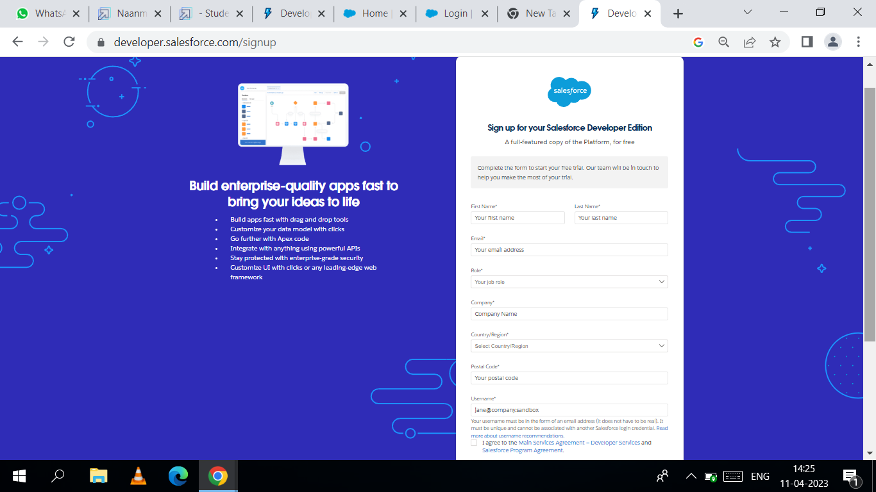

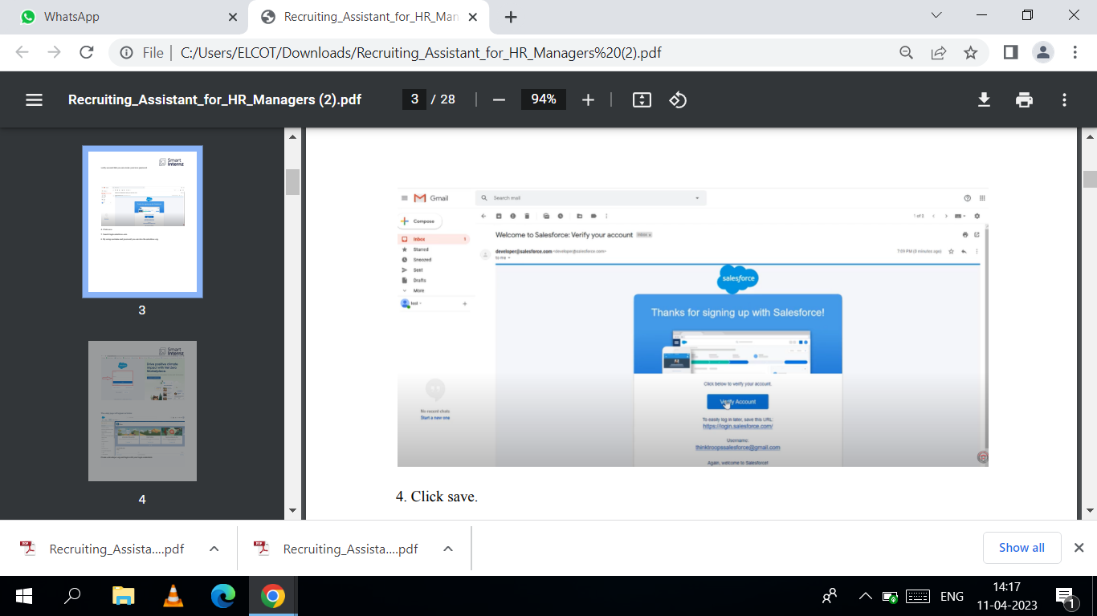

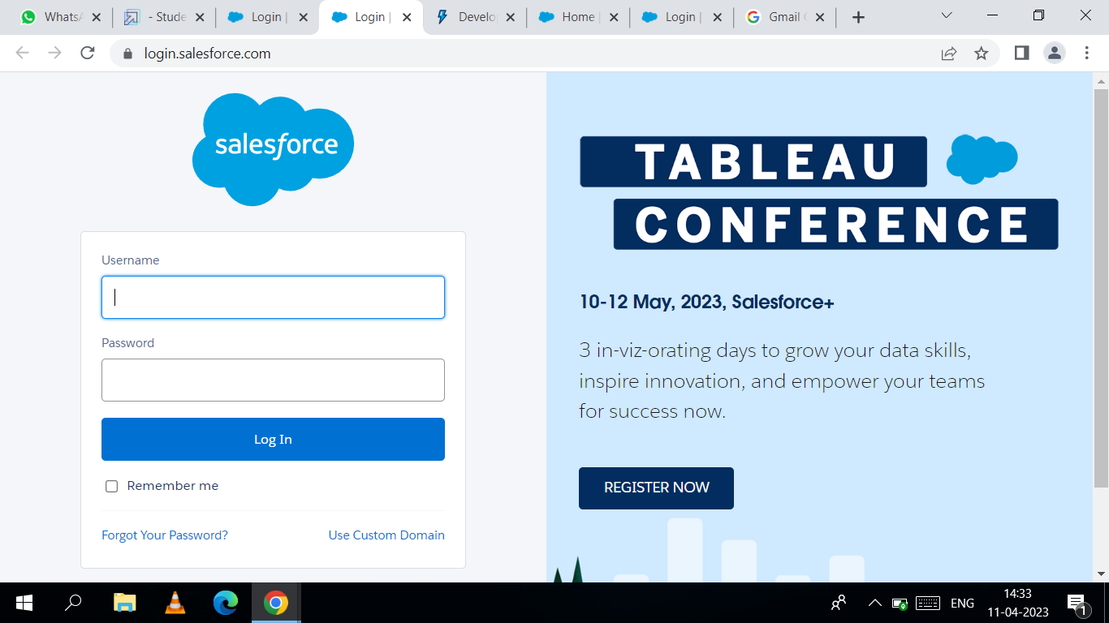

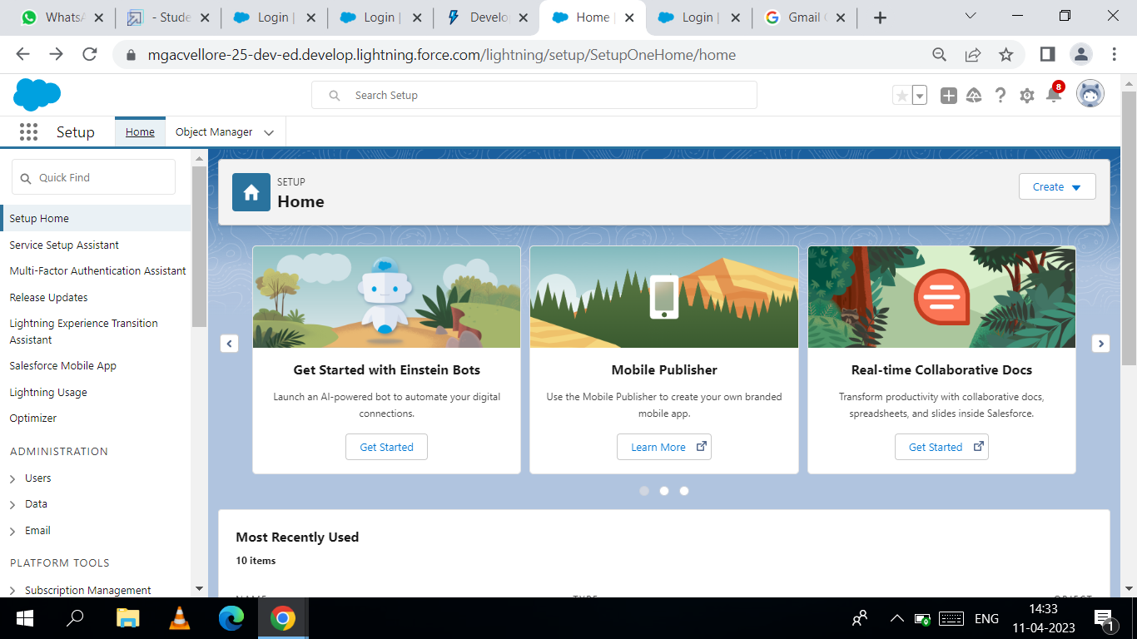

MILESTONE 2:

**STEP 1:** Click the app launcher, then click the playground starter and Create a custom

object review.

**STEP 2:** Go to the package installation in this place in verify 100 points and type a

**RECURING FOR HR MANAGER** and then launch.

**STEP 3:** Now paste the package **id 04t0P000000N9rs** then click the install and select

for admin only. 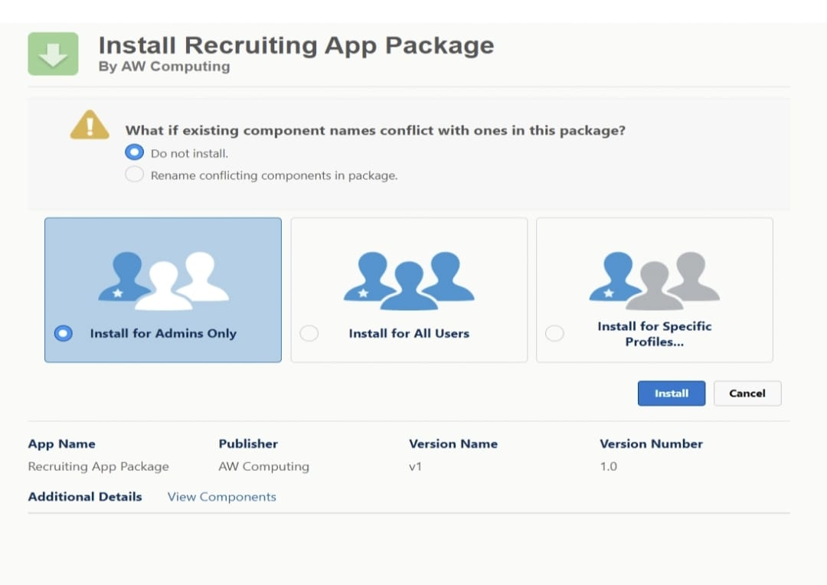

MILESTONE 3:

**STEP 1:** From go to the set up and click on the **object manager** and then click on create for **custom**

**object.**

**STEP 2:** fill in the label as **“Job Posting Site**” and fill in the plural label

**“Job Posting Sites”.**

**STEP 3:** record name **: “site name”**

**Step 4**: select the data type **: text** and then go to the optional feature section select and

allow reports and track field history .

**Step 5**: In the Deployment Status section, secure Deployed is selected, and

search Status section, select Allow Search.

**Step 6: I**n the object Creation Options se3ction, select these options:

Add Notes and Attachments related list to default page layout and launch New Custom Tab

Wizard after saving this custom object.

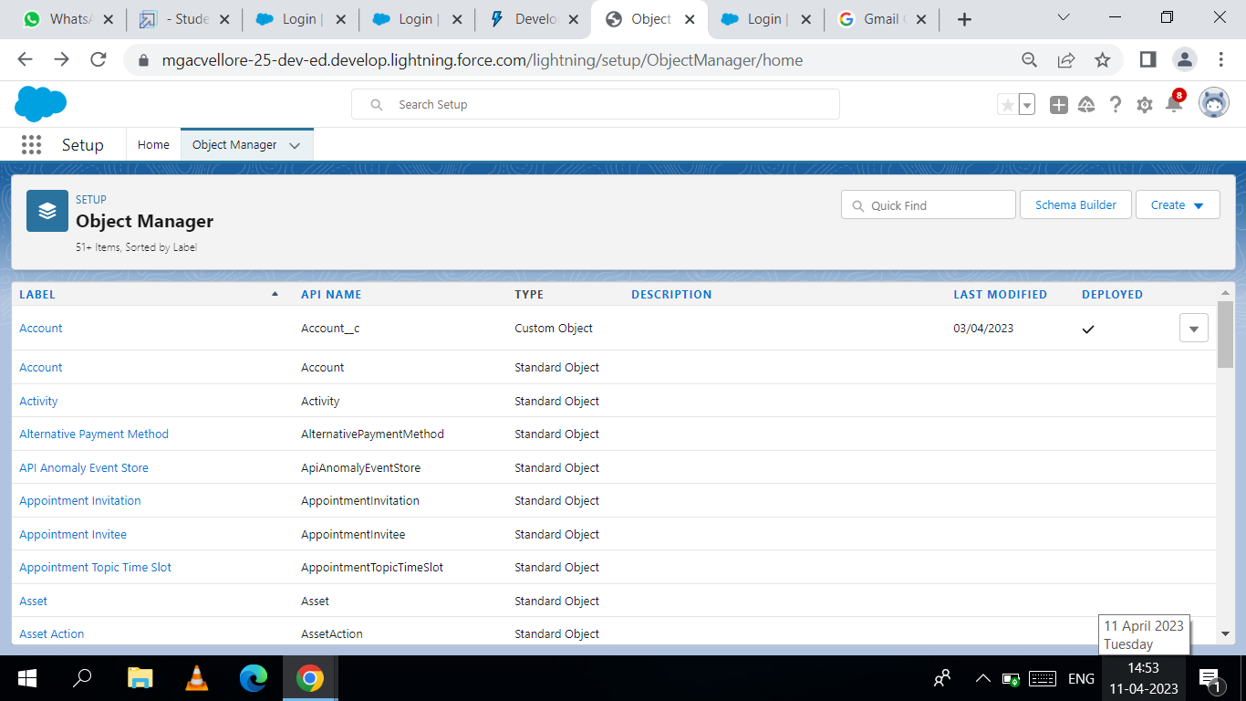

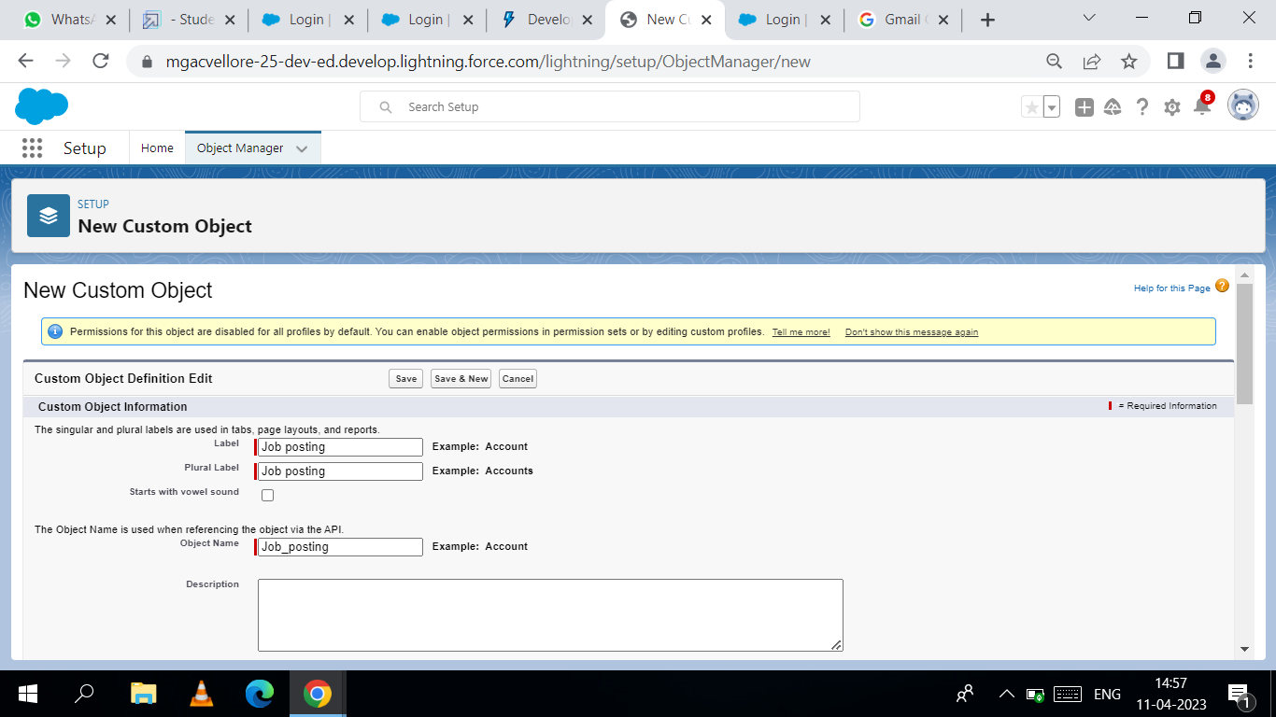

MILESTONE 4:

**STEP 1:** As we selected to launch a custom tab wizard in step 10,

a custom tab appears wherein we customize the look of the job

posting site object’s tab.

**Step 2:** Click the next button and leave the profile as is and click Next.

Step 3: In the add to the Custom Apps section:

Step 4: Deselect Include Tab. And Select Append tab to users’ existing personal Customization

And the click save. 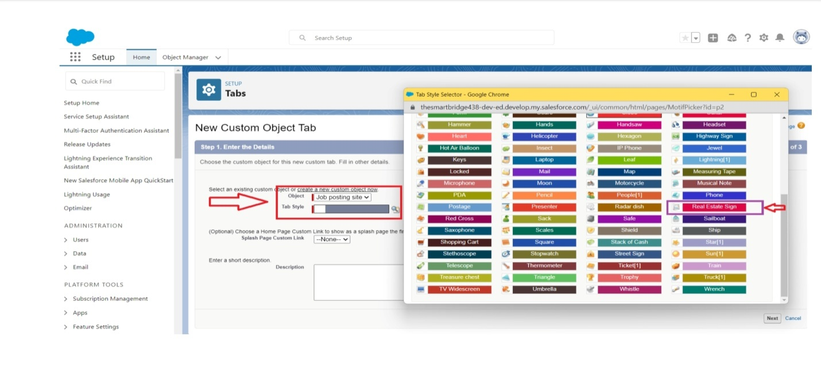

MILESTONE 5:

**STEP 1:** From the object manager, click on the job posting site, then click on Fields & Relationship.

**STEP 2:** Click on new and Click Next.

**STEP 3:** For Field Label, enter the Job Posting Site URL.

STEP 4: Click next, and Click Save & new and create a field for Job Posting Site

1. Status
2. Technical site
3. Description

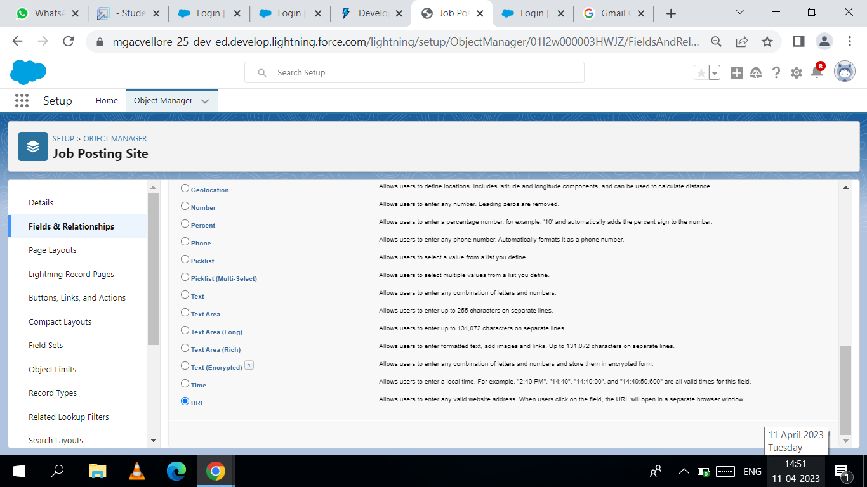

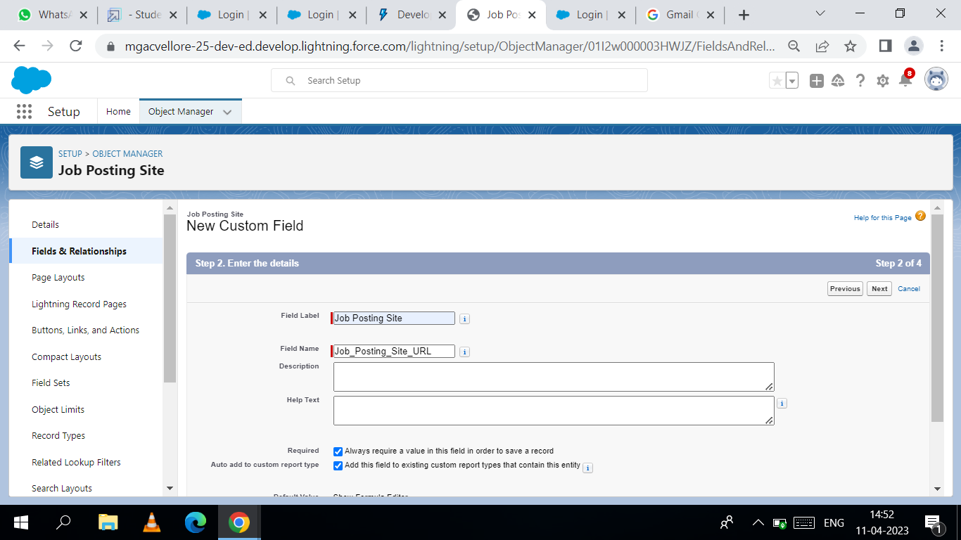

MILESTONE 6:

**Activity 1:**

**Creating a custom junction object :** 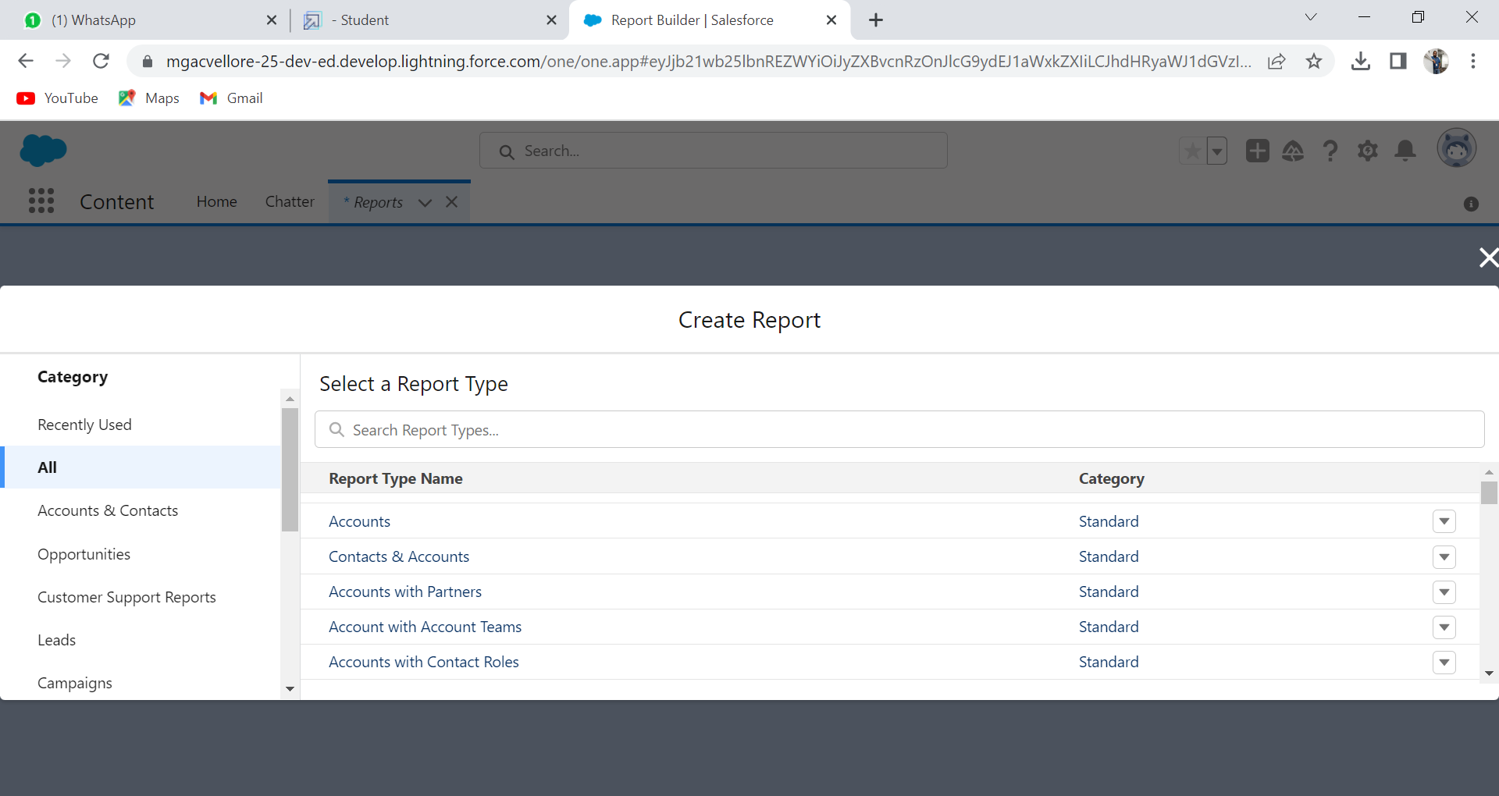

**STEP 1:** From setup, click object Manager and Click create, select custom object.

**STEP 2:** Enter the label as "Job posting" and enter the plural label as "Job postings"

**STEP 3:** Enter the record name as "Job posting number".

**STEP 4:** select the data type as "Auto Number”. Enter the display format As

**STEP 5:**  Leave everything else as is, and click save.

**Activity 2:**

**Create a Relationships Object Creating a master-detail**

**STEP 1:** From setup, click object manager and Select Job posting

click on field and relationships, click relationship between Job posting and job posting.

**STEP2:** Select the data type as Master-detail relationship.

**STEP 3:** Click Next, relate to the Job posting site.

**STEP 4:** Enter the label Job Posting site and Click next, next, next and save

Creating a master-detail relationship between job posting and position

**STEP 5:** From setup, click object manager and Select Job posting object,

click on field and relationships, click new and Select the data type

as Master-detail relationship.4. Click Next, relate to position.

**Step 6:** Enter the label Position.6. Click next, next, next and save.



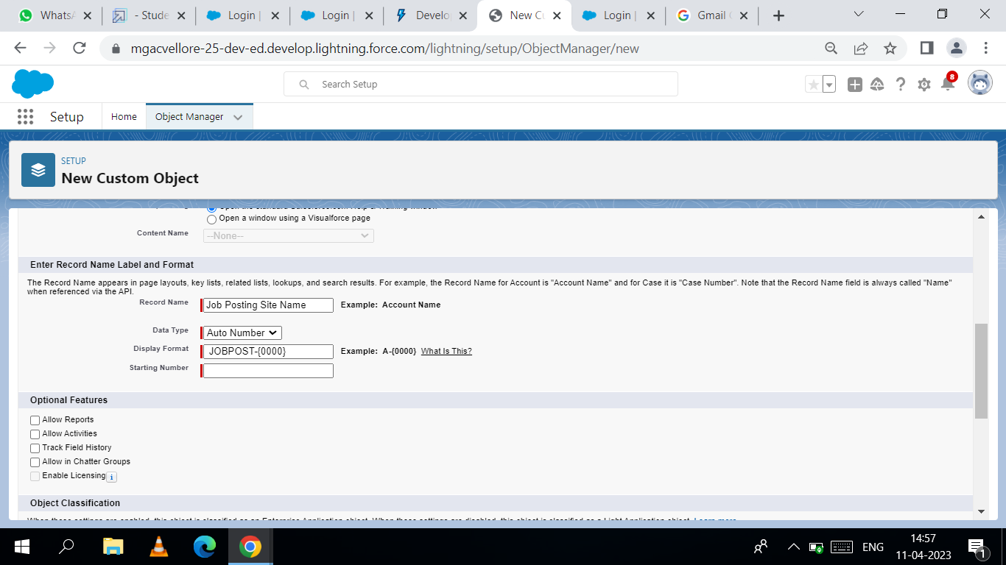

**MILESTONE 7:**

**Activity 1:**

**Modifying the page layouts :**

**STEP 1:** From setup, click on object manager.

**STEP 2:** Click position, then page layouts**.**

**STEP 3**: Click down array next to the position layout and select edit and then Scroll down to

the job posting related list, and click the wrench icon in the header to edit it.

**STEP 4**: From the available fields section, select Job posting site : Status Job posting site : TechnicalSite.

**STEP 5:** Click add and From the selected fields section, select job posting

: Job posting number and click remove.

**Step 6:** Click ok, then save.

**Activity 2:**

**Create a Page layout for Review Object.**

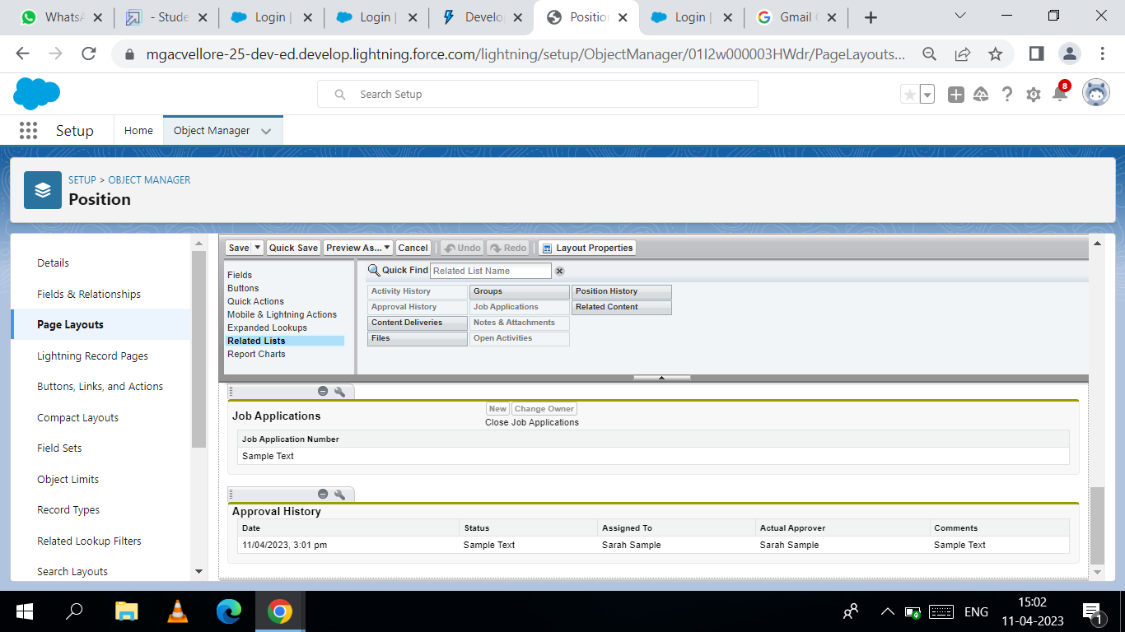

**MILESTONE 8:**

**Activity 1:**

**Modifying the page layouts :**

**STEP 1:** To create a validation rule: Go to object manager, select the object on which validation

rule has to be implemented, scroll down and click validation rule, New.

**STEP 2:** Give details as:1. Rule name: Phone number validation rule.

**STEP 3**: Active: checked3. Description: phone number should not be more than or less than

10 digits.

**STEP 4**: Under Error Condition Formula: write the condition using insert field,

insert operator, insert function5. Using check syntax:

check if the formula you entered is valid or not.

**STEP 5**: Error Message: Please give a valid phone number.

**STEP6:** Error location: select field and Save.

**Activity 2:**

**Create a Validation rule For Technical Site Checkbox is equal to True.**

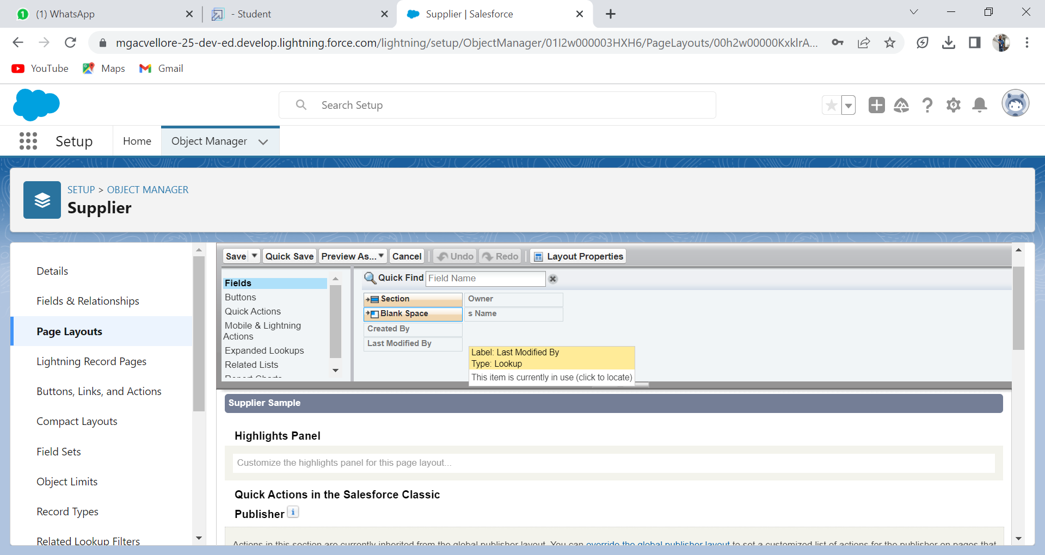

**MILESTONE 9:**

**Activity 1:**

**Creation on profile:**

**STEP 1:** From Setup enter Profiles in the Quick Find box, and select Profiles.

**STEP 2:** From the list of profiles, find Standard User and then Click Clone and For Profile

Name, enter Event user profile.

**Step 3**: Click Save and while still on the event profile page, then click edit.

**Activity 2:**

**Create a profile with the profile name as “Sales profile”**

**Step 1:** user.

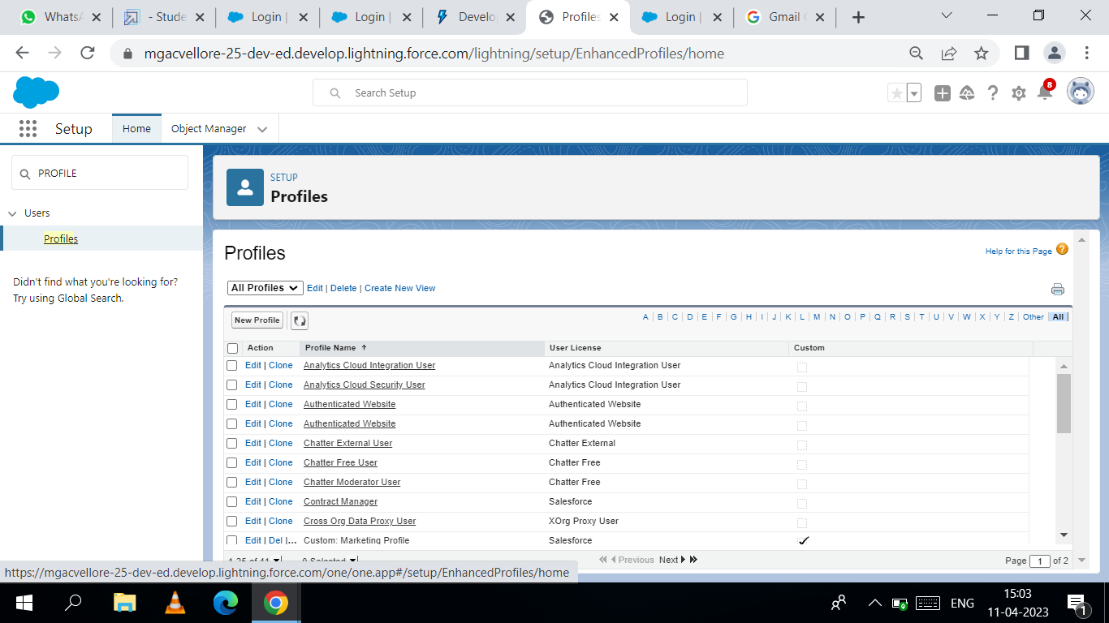

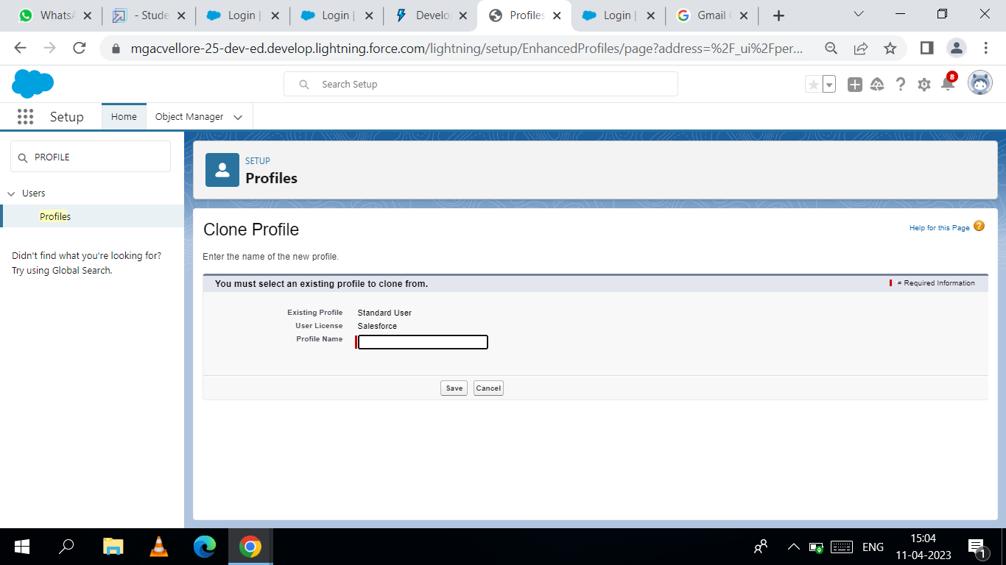

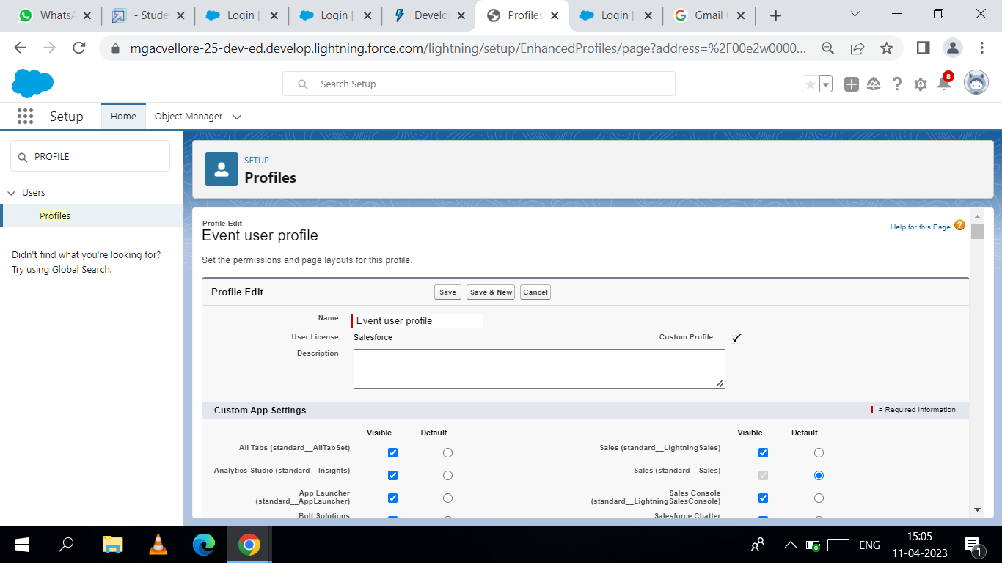

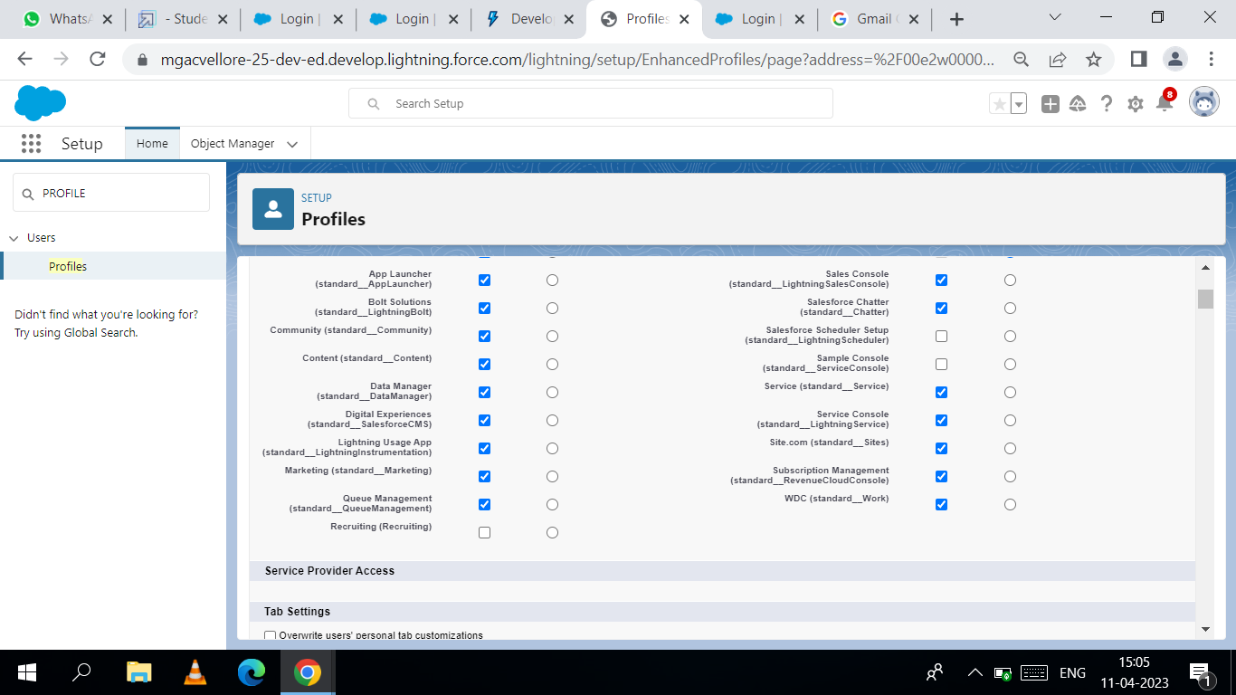

MILESTONE 10:

**Activity 1:**

**Creating a User:**

From setup type “users” in quick find and select users, then click New User

**First Name: Sanjay.**

**Last Name: Gupta·**

**Alias: Sanj.**

**Email: provide your personal email id for future reference·**

**Username:** [**sanjaygupta@thesmartbridge.com·**](mailto:sanjaygupta@thesmartbridge.com·)

**Nickname: Sanju·**

**Role: leave it as default·**

**User License: Sales force·**

**Profile: Event User Profile.**

**Activity 2:**

Create a user with a username as **“Abhilash Garapati”**, and assign him the sales profile.

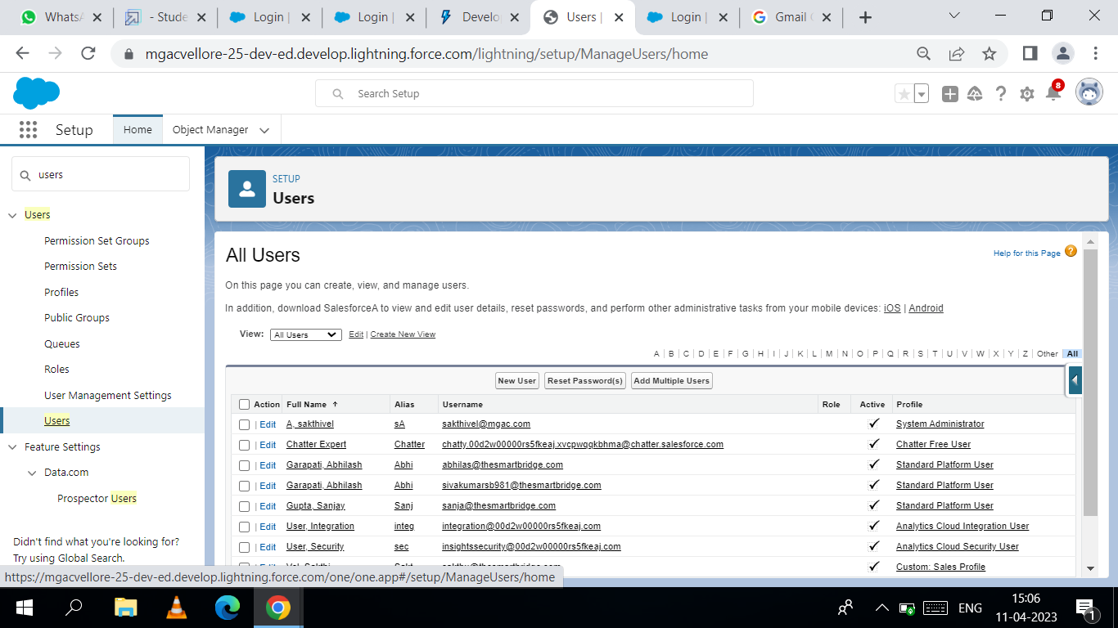

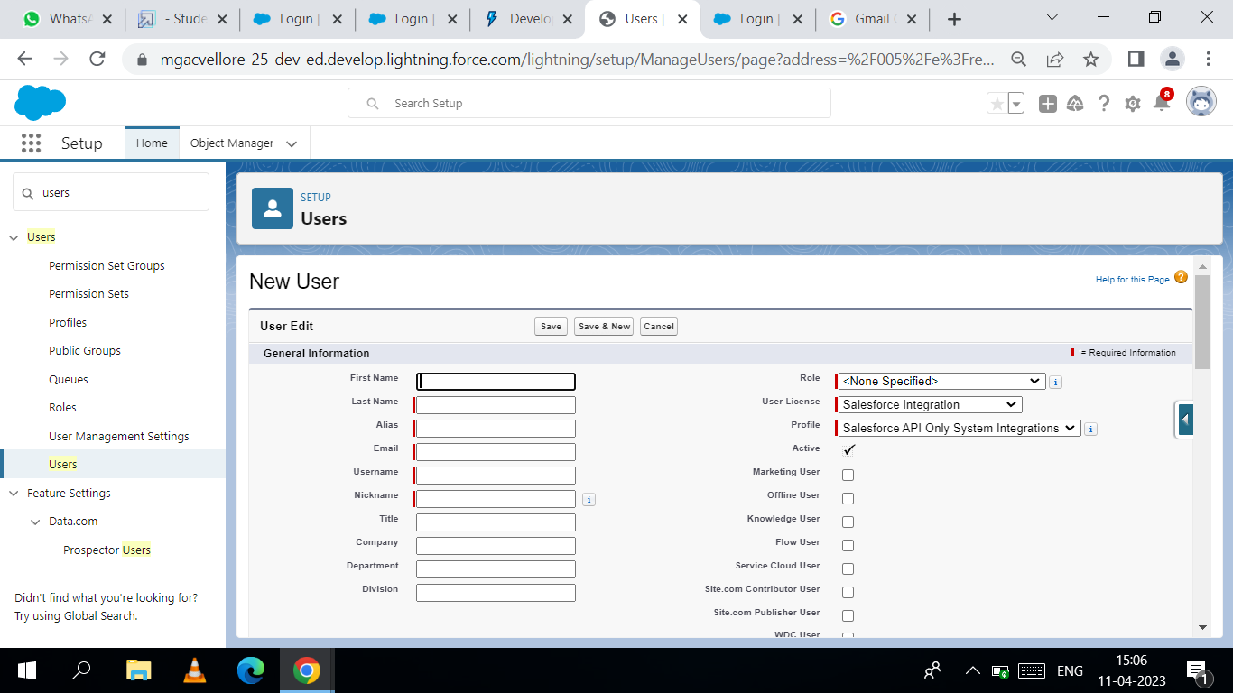

**Milestone 11:**

**Activity 1:**

Creating a Permission Set:

**STEP 1:** From setup search “permission sets” in quick find and select permission set

then click on New.

**STEP 2:** Enter label as: Supplier Permits and Save.

**STEP 3:** After saving the permission click on the Manage assignment

**STEP 4:** Now click on the Add Assignment.

**STEP 5:** Now select the users and click on save.

**Activity 2:**

Create a Permission set for Review object.

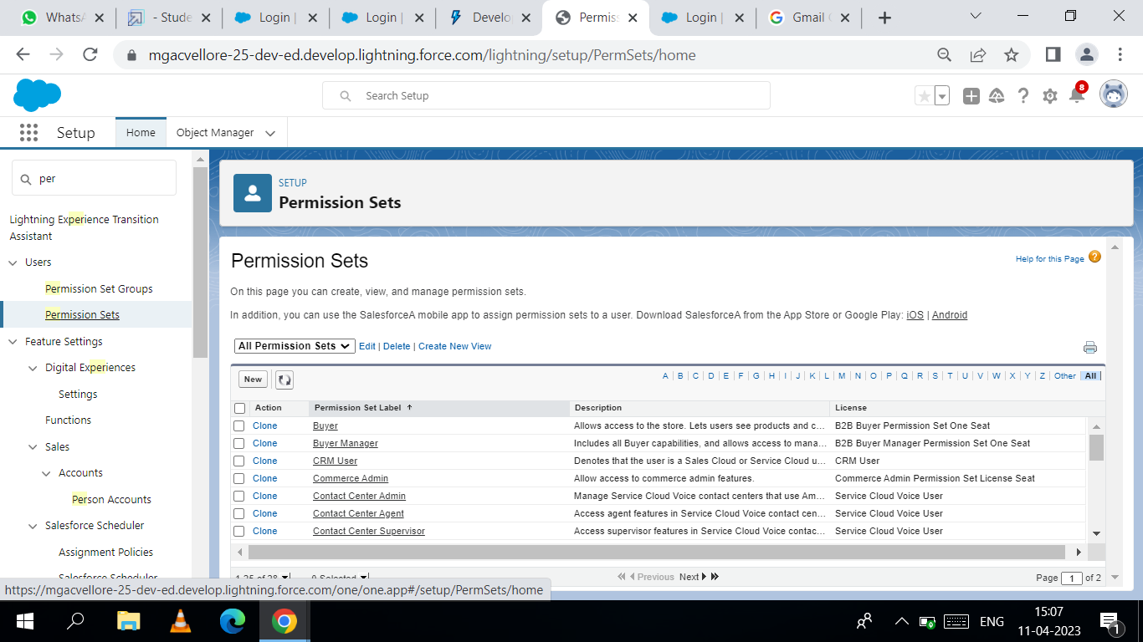

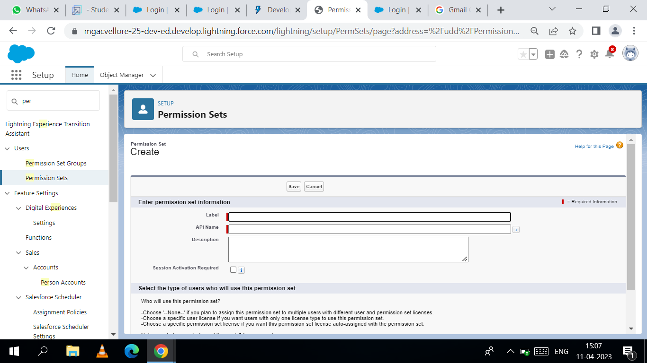

Milestone 12:

**REPORTS:**



**STEP 1:** In the app launcher search the report and click it. On our right side new report

Option is available click it. Select a report in a find box, the reports are in object

name like as Semester, Lecturer Details etc… click it, on our right side start report

option will be showed click it and finish the reports. Click the save & run option.

**THE END...**

**Our Sincere Thanks to**

**SALESFORCE**

**SMARTBRIDGE (Smart Internz)**